**14 – Time-Retarded Potentials**

**Topics:** Retarded time, time-retarded potentials and fields.

**Summary:** Students explore the concept of *retarded time* for the case of an infinitely long wire with a current that abruptly starts at *t* = 0. They first consider the points in space where an observer would be aware of there being a non-zero current a short time after it starts. Students find that the retarded time has different values at different points in space (relative to an observer at the origin), and decide on the limits of integration for finding the retarded vector potential at the origin. Challenge questions at the end have students calculate the electric field at the origin, and check their answer in the limit of long times.

**Written by:** Charles Baily, Michael Dubson and Steven Pollock.

**Contact:** Steven.Pollock@Colorado.EDU

**Comments:** Students should be able to complete these tasks within 30 minutes. Although it is fairly intuitive to students that it takes a finite amount of time for effects to propagate from a source to an observer, the definition of *retarded time* (and how it is used in a calculation) is not. In particular, that the retarded time is a function of two coordinate variables, and has different values at different points in space relative to a fixed observer. We verbally emphasized at the beginning that the tick marks are scaled in a way that simplifies the problem, and there didn’t seem to be any confusion about this during the tutorial. There is a “time ruler” on a separate handout that students can use for the questions on the first and second page – they may need some guidance about how many points along the wire to consider (it doesn’t need to be very many); they may also need a gentle reminder that it’s easiest to work with whole numbers for the distance from the origin (some were tempted to estimate the distance for points on the wire that were even with the tick marks on the *x* and *y*-axes). There were some students confused about what the primed and unprimed variables are each referring to, which typically shows up in problems involving the separation vector . The tasks in the *challenge questions* at the end are similar to Example 10.2 in Griffiths, but a simpler method (involving the fundamental theorem of calculus) is used for calculating the electric field from the retarded vector potential.

**A.** An infinitely long wire has a current that is turned on abruptly at *t* = 0. The function  describing this current is:



NOTE: The *x* and *y* dimensions on the graphs below are scaled so that each tick mark represents the distance light would travel in one time unit. You can use the “time ruler” on the handout to measure distances.

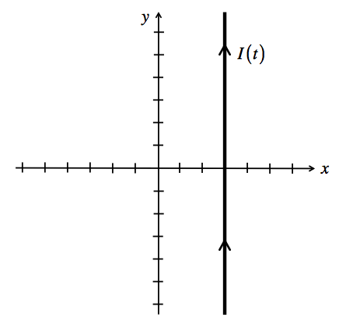

Indicate on the graph all of the points in space  where an observer would be aware of a non-zero current in the wire at *t* = 2.



Imagine you are an observer at the origin (). Use your “time ruler” to mark the distance  from the origin for several points up and down the wire. What is the retarded time  at each of these points when *t* = 5?

:::::Screen shot 2012-06-01 at 2.49.15 PM.png



For an observer at the origin, indicate on the graph all of the points on the wire for which the observer is aware of a non-zero current at *t* = 5. That is, where on the wire is ?

**B.** Recall that in the Lorentz gauge, the retarded vector potential will be:



Re-write this equation for the vector potential **at the origin** in terms of the constant . Be sure to specify the correct limits of integration, which will be a function of time.

**Challenge Questions:**

We want to be able to compute the electric field from .

Recall the fundamental theorem of calculus:



Then, by the chain rule:



Use this to compute the electric field  at the origin.

What is the electric field at the origin in the limit ? Explain in words why your answer makes sense.